**Sources of funding**

Bank Loan

* Be able to make the repayments
* Chance of not being approved
* Give the bank a realistic forecast
* Able to borrow as much as you like, providing you can repay it

Crowd funding

* Easy to setup via the Internet
* Give away shares
* Give away equity
* Gofundme and Kickstarter are two popular examples

Grants

* Free money
* Generally have to meet the terms and conditions
* A lot of competition

**Funding central**

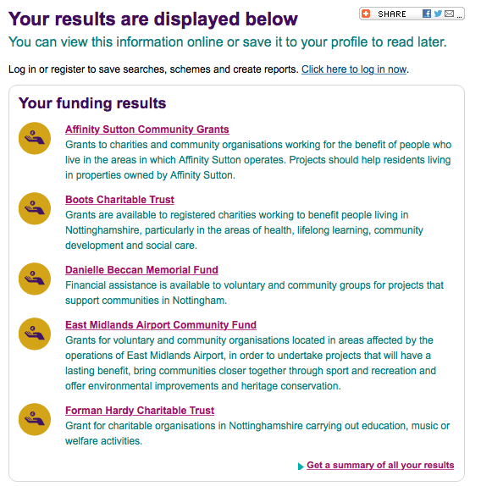

**Danielle Beccan Memorial Fund**

Max value - £5,000

Min value - £500

Deadline – Passed, may open again later in the year

Community or voluntary groups in Nottingham who work to improve their communities.

**Forman Hardy Charitable Trust**

Budget – Unknown

Deadline – Continuous

* Children and young people
* Health and medial care
* Music

**East Midlands Airport Community Fund**

Max Value - £2,000

Deadlines – 8th April 2016, 22nd July 2016, 23rd September 2016, 25th Novmeber 2016

Groups must be located in the surroundings of EMA

* To bring the community closer together through facilities for sport, recreational and other leisure time activities.
* Offer environmental improvement and/or heritage conservation.
* Improve awareness of environmental issues through environmental education.

Encourage and/or protect wildlife.

Restrictions

Recurrent expenditure or running costs – printing, web design, promotional material

**Boots Charitable Trust**

Minor grants of under £2,000 – 1-2 months to administer

Major grants of over £2,000 – 2-4 months to administer

Donations range from £100 - £10,000 per year, although larger amounts may be considered

Deadlines – 7th of each month if applications for grants exceed £2,000

* Health:
  1. Community Healthcare - community healthcare services, home care, after care, sufferers of medical conditions, disabled people and continuing care.
  2. Health Education and Prevention - promoting knowledge and awareness of specific diseases or medical conditions.
* Lifelong Learning:
  1. Helping people of any age to achieve their educational potential (supplementary schools, literacy and numeracy projects, community education, vocation/restart education for the unemployed, alternative education for excluded school pupils).
* Community Development:
  1. Helping groups to organize and respond to problems and needs in their communities or networks.
  2. This could include groups such as Councils for Voluntary Services and Citizens Advice Bureaux.
* Social Care:
  1. Personal Social Services - organizations assisting individuals or families to overcome social deprivation (e.g. people who are homeless or disabled and their carers, lone parent and childcare groups and other family support groups).
  2. Social Preventive Schemes - activities preventing crime, dropping out and general delinquency and providing other social care outreach work, social health and safety awareness schemes, etc.

Community Social Activities - activities to promote social engagement for vulnerable people, mitigating against isolation and loneliness.

Restrictions

Not eligible for funding – people outside Nottingham, organisations which are not registered charities and which have an income or expenditure of more than £5,000 per year

**Affinity Sutton Community Grants**

Max value - £5,000

Min value - £1,000

Deadline – Passed, may open again later this year

* Engaging young people in positive activities.
* Supporting children and families.
* Promoting the green agenda and estate regeneration.
* Promoting health and wellbeing.
* Improving community safety.
* Encouraging community cohesion.
* Promoting equal opportunities.

Restrictions

* Be primarily supporting Affinity Sutton residents. Applicants will be expected to have researched Affinity Sutton presence in the area and be able to demonstrate that they have a clear strategy for engaging Affinity Sutton residents in their project
* Have a minimum of three un-related Management Committee members.
* Have a governing document (eg a constitution or set of rules).
* Have a bank account in the name of the group, with at least two unrelated signatories – or provide details of another group who will be managing any grant awarded.
* Have a record of income and expenditure (applicants that are a new group with no previous income will need to provide a bank statement) or set of accounts.
* Have a “safeguarding policy” if working with young people under the age of 18, or if working with vulnerable adults.
* Have a health and safety policy in place.
* Have the relevant insurance in place, including public liability where required, before delivering activities.

Have an annual income under £500,000 (organizations with an annual turnover of over £500,000 wishing to deliver a project for the benefit of Affinity Sutton residents are advised to consider working in partnership with a local organization that falls within the income threshold).

Purely for profit (commercial ventures)

Projects with no clear plan to benefit Affinity Sutton residents